# **Background**

My friend uses [KeePass](https://keepass.info/) as a password manager and unfortunately forgot the master password. Normally it's a [lost cause](https://superuser.com/a/80380) to brute force however my friend remembers a good chunk of his password. Instead of having to reset all of his accounts we decided to try our hand at cracking the vault.

**Table of Contents**

* [Basic Crack](https://docs.google.com/document/d/e/2PACX-1vSQmJSuBLDtEGuvAVp5GQR4FM-bM0_pEs6ia0tWQ_-X5ZwFUeGQdqZYIXFQlJLSPv9At95cCiOGJPp2/pub?embedded=true)
  + [Setup Vault](https://github.com/spencermwoo/Cracking/tree/master/KeePass#setup-vault)
  + [Setup Crack](https://github.com/spencermwoo/Cracking/tree/master/KeePass#setup-crack)
  + [Running Hashcat](https://github.com/spencermwoo/Cracking/tree/master/KeePass#running-hashcat)
* [Hash Crack](https://github.com/spencermwoo/Cracking/tree/master/KeePass#hash-crack)
  + [Testing Hash](https://github.com/spencermwoo/Cracking/tree/master/KeePass#testing-hash)
  + [Investigation](https://github.com/spencermwoo/Cracking/tree/master/KeePass#investigation)
  + [Debugging](https://github.com/spencermwoo/Cracking/tree/master/KeePass#debugging)
* [Finale](https://github.com/spencermwoo/Cracking/tree/master/KeePass#finale)

# **Basic Crack**

Our first step was to successfully crack a simple vault. If this was possible we had promise in cracking the real thing.

### **Setup Vault**

We visited [KeePass downloads](https://keepass.info/download.html) and installed KeePass version 2.38.

We then created a basic database with a password from [pwqgen](https://pwqgen.herokuapp.com/)

Saudi7settle+Strap

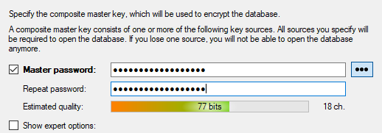

And called it test.kdbx.

### **Setup Crack**

We now have our vault but still need to

1. convert it into a crackable hash

We grabbed [HarmJ0y's keepass2john.py](https://github.com/spencermwoo/Cracking/blob/master/KeePass/test/keepass2john.py) and used it to generate a crackable hash from our test.kdbx vault, saving the hash as test.hash.

$ python2 keepass2john.py test.kdbx

test:$keepass$*2*60000*222*a339edcdaf7d1216d4016b5d80c7e5560e1278f54c963d78cec26c8f388b87ec*f552cf7fd8209a99cdbc957bca9eda067c83d5c8f6bdcd810eb35628661dffa8*4cd47adb5446f6c95eebed4c34128f19*0fab1f230bf8b5b3c32ba5c33ec3cd2501c41dc7d07504651393c596d27f7357*4c7de0a343dfcac9cd62fdec0eb1b4ecc75366f750b0311d3729f4de004f6e91

1. create a password list.

We grabbed a wordlist from [berzerk0's Probable-Wordlists](https://github.com/berzerk0/Probable-Wordlists/blob/master/Real-Passwords/Top207-probable-v2.txt) and [added our password](https://github.com/spencermwoo/Cracking/blob/master/KeePass/wordlists/Top207-probable-v2.txt#L203) near the end.

### **Running Hashcat**

Now we have a hash file that is compatible with hashcat and should be cracked with our wordlist.

We looked up the [types of hashes](https://hashcat.net/wiki/doku.php?id=example_hashes) that hashcat can handle and found the Keepass 2 section, specifically 13400 Keepass 2 AES / with keyfile. We modified our test.hash (removing the "test" database reference in the beginning) to conform our hash to the provided example of a valid 13400 hash.

* Hash $keepass$*2*60000*222*a339edcdaf7d1216d4016b5d80c7e5560e1278f54c963d78cec26c8f388b87ec*f552cf7fd8209a99cdbc957bca9eda067c83d5c8f6bdcd810eb35628661dffa8*4cd47adb5446f6c95eebed4c34128f19*0fab1f230bf8b5b3c32ba5c33ec3cd2501c41dc7d07504651393c596d27f7357*4c7de0a343dfcac9cd62fdec0eb1b4ecc75366f750b0311d3729f4de004f6e91
* Example Hash $keepass$*2*6000*222*15b6b685bae998f2f608c909dc554e514f2843fbac3c7c16ea3600cc0de30212*c417098b445cfc7a87d56ba17200836f30208d38f75a4169c0280bab3b10ca2a*0d15a81eadccc58b1d3942090cd0ba66*57c4aa5ac7295a97da10f8b2f2d2bfd7a98b0faf75396bc1b55164a1e1dc7e52*2b822bb7e7d060bb42324459cb24df4d3ecd66dc5fc627ac50bf2d7c4255e4f8*1*64*aaf72933951a03351e032b382232bcafbeeabc9bc8e6988b18407bc5b8f0e3cc

We ran [hashcat](https://hashcat.net/hashcat/) on our hash file with our dictionary.

$ ./hashcat64.exe -m 13400 test.hash Top207-probable-v2.txt

Success!

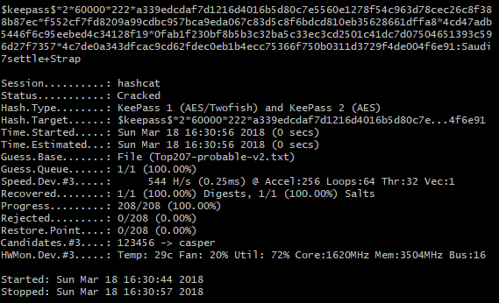

We've successfully put the pieces together to crack a basic .kdbx file!

# **Hash Crack**

It turns out the major pieces to crack a KeePass database are

1. the hash generated from our .kdbx file and
2. a proper wordlist.

We have our .kdbx file, so all that's left is a proper wordlist? Not so fast.

Another difference with a real-world example is the [hash iterations](https://en.wikipedia.org/wiki/Cryptographic_hash_function). When creating the vault my friend significantly increased the hash iterations such that logging in normally would take about a second each time. Specifically when creating the vault he used the Security > 1 Second Delay option to use a 'deterministic random' hash iteration count.

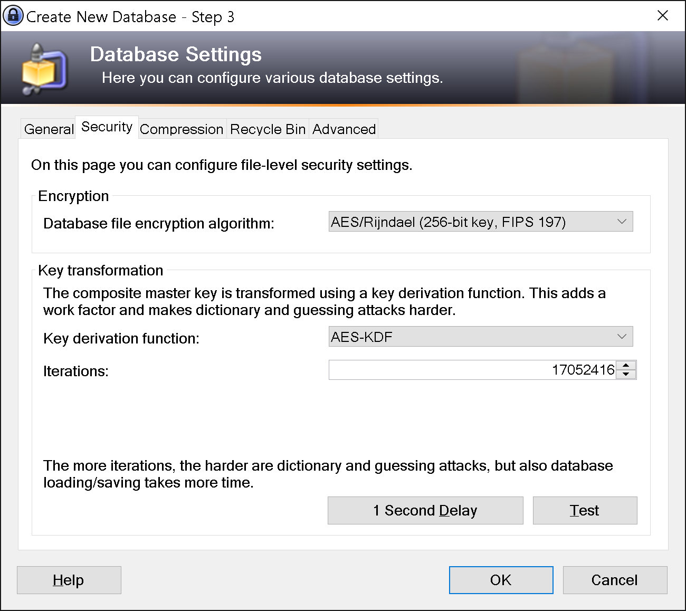

Will our steps work with increased hashes?

### **Testing Hash**

We create a new database using password Saudi7settle+Strap and increase the iterations.

We run the python script, remove the database name, and save the hash as hash_test.hash

$ python2 keepass2john.py hash_test.kdbx

$keepass$*2*27648*222*5bad084314051bc38d439d3211317fdba5dca739eac923ccaa2bb21d1de5178f*835ccf2cd3db3874be7d655c1f31887248d2e7025bfd61bb5c19862a0cb0d3d8*9cc0b342fce5cfa55ec830f1443efa69*0fbe057ea7fc655800ab354cbdc3b79eaf1a6eb5fce14312e6ab450bb445d139*f6f984c16ffaedacb2aaedd70c7e54136ccc31fe78bd31c17996e0647453a6ef

We run hashcat with our same [wordlist](https://github.com/spencermwoo/Cracking/blob/master/KeePass/wordlists/Top207-probable-v2.txt#L203).

$ ./hashcat64.exe -m 13400 hash_test.hash Top207-probable-v2.txt

And the list is exhausted.

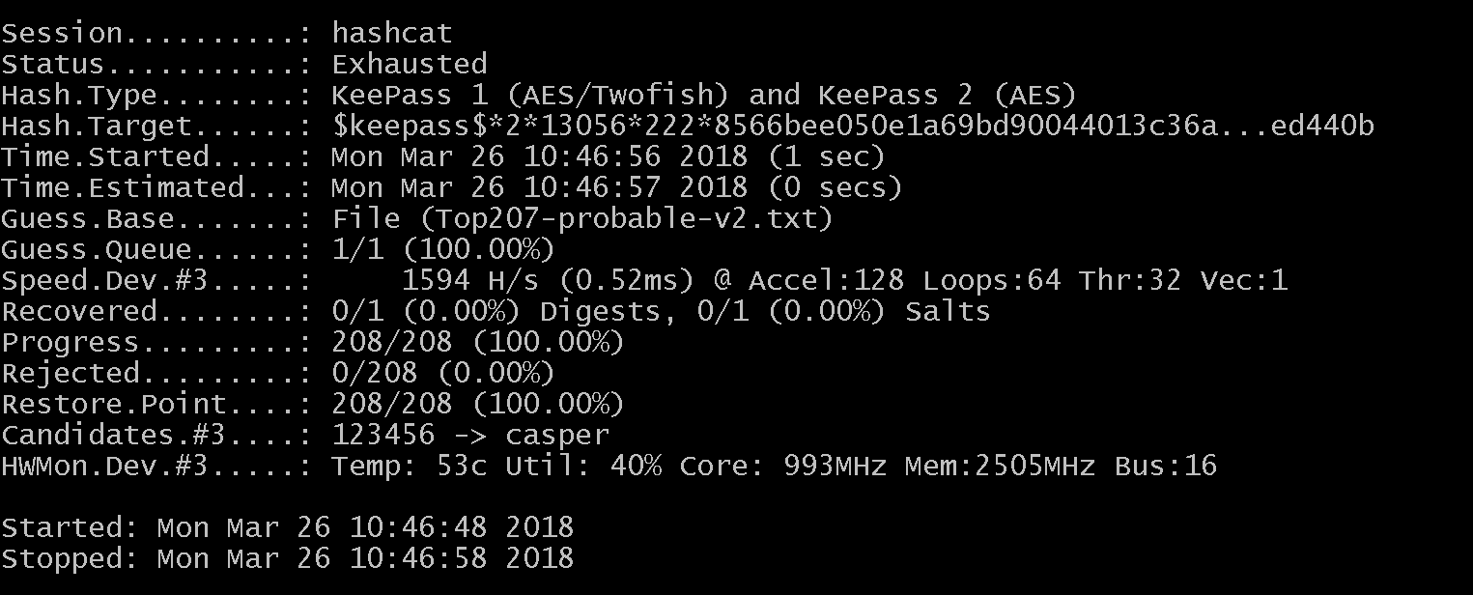

Oh no! The password is in the wordlist, why isn’t it successful?

It seems increasing the hash iterations breaks our use case. Let's find out what's happening!

### **Investigation**

We compare the two hashes

* Default $keepass$*2*60000*222*a339edcdaf7d1216d4016b5d80c7e5560e1278f54c963d78cec26c8f388b87ec*f552cf7fd8209a99cdbc957bca9eda067c83d5c8f6bdcd810eb35628661dffa8*4cd47adb5446f6c95eebed4c34128f19*0fab1f230bf8b5b3c32ba5c33ec3cd2501c41dc7d07504651393c596d27f7357*4c7de0a343dfcac9cd62fdec0eb1b4ecc75366f750b0311d3729f4de004f6e91
* Iterations $keepass$*2*13056*222*8566bee050e1a69bd90044013c36a76ed0cda2e85133c2f0ea95018cf97a5982*e1bbc858fc6ad4d726e778e1db6dfb6d84143f96be51f387ba89610c4c1cefe7*7ceed46e2420ec4c68a1d6cc8bb872ec*7bc6c7a6398e3d7ad472fc9afedb58578ccf04d9e7d03eda3d20a9d02e1932a2*fbbf4725cf5bc99b928ad2cbddef00d4a20ef4a73bf56ba5a68ba31047ed440b

We note that the third parameter (asterisk-delimited) has changed and seems to relate to the hash iterations. We confirm this by looking at the code and indeed the third parameter is [transformRounds](https://github.com/spencermwoo/Cracking/blob/master/KeePass/test/keepass2john.py#L114). We conjecture that transform rounds should be our 17052416 value from using the 1 Second Delay and our basic crack worked because 60000 is the default transformRounds.

We test this hypothesis by manually replacing the transformRounds value with our expected value in our hash file.

$keepass$*2*17052416*222*5bad084314051bc38d439d3211317fdba5dca739eac923ccaa2bb21d1de5178f*835ccf2cd3db3874be7d655c1f31887248d2e7025bfd61bb5c19862a0cb0d3d8*9cc0b342fce5cfa55ec830f1443efa69*0fbe057ea7fc655800ab354cbdc3b79eaf1a6eb5fce14312e6ab450bb445d139*f6f984c16ffaedacb2aaedd70c7e54136ccc31fe78bd31c17996e0647453a6ef

We run hashcat again, fingers crossed.

$ ./hashcat64.exe -m 13400 hash_test.hash Top207-probable-v2.txt

Hashcat runs for a significantly longer time...

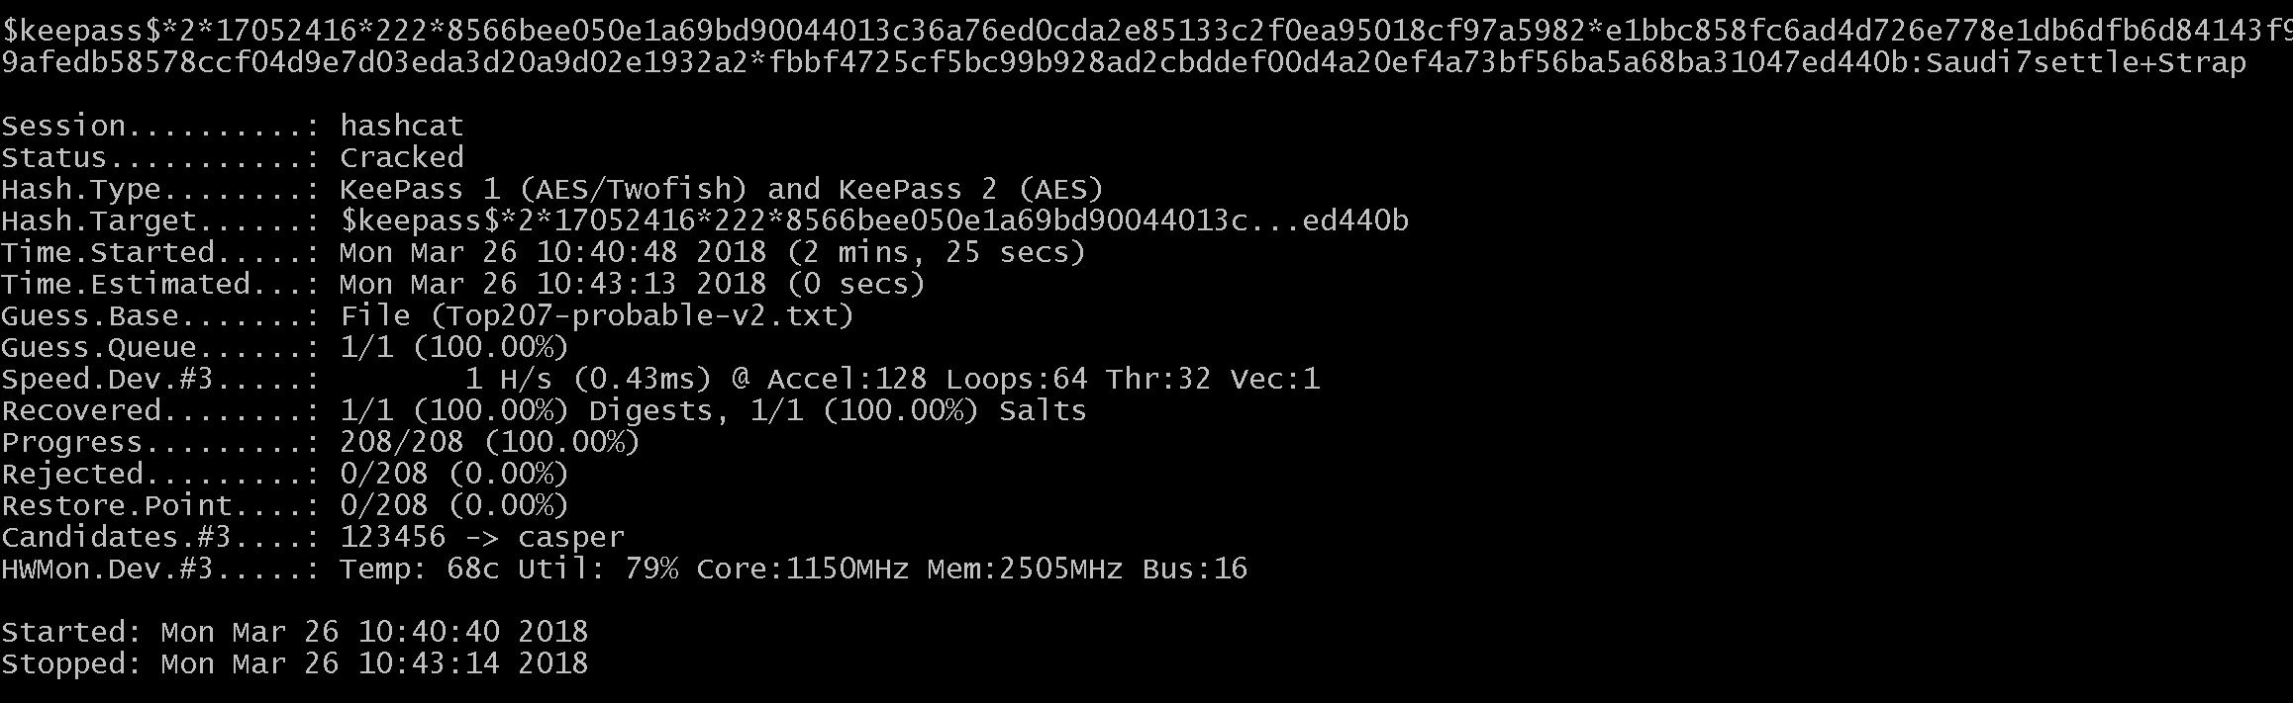

Success!

### **Debugging**

We've now determined that if we can properly calculate the transformRounds value we can successfully attack the real vault however our program isn't properly calculating this value.

We play around with different databases with increased hash sizes and note that everytime the transformRounds value is different. This is reassuring because it indicates that our script knows that the keepass.kdbx file's transformRounds is changing and isn't the default 60000 and is trying to calculate the correct number.

We dive into the python program and look at the code, specifically looking at how [transformRounds is calculated](https://github.com/spencermwoo/Cracking/blob/master/KeePass/test/keepass2john.py#L101).

transformRounds = struct.unpack("H", data[index:index+2])[0]

We look at [Python's struct](https://docs.python.org/2/library/struct.html#struct.unpack) and specifically that the first parameter is a [format character](https://docs.python.org/2/library/struct.html#format-characters).

We looked at all our transformRounds values (13056, 27088, etc). Notice they're all lower than the default 60000. Wait. H is an unsigned int -- it's too small!

Looking at the [Python format characters](https://docs.python.org/2/library/struct.html#format-characters)

H unsigned short integer 2 (3)

H is an unsigned short which is 2 bytes or 16 bits. This can only hold values up to 2^16 or 65536. Our value of 17052416 is larger than 65536 and it turns out that 17052416 % 65536 = 13056. We were overflowing the unsigned short!

Q unsigned long long integer 8 (2), (3)

Q is an unsigned long long which holds 8 bytes or 64 bits. This can hold values up to 2^64 or 18446744073709551616. Much better!

We update [transformRounds](https://github.com/spencermwoo/Cracking/blob/master/KeePass/hash_test/keepass2john.py#L101) to use Q.

transformRounds = struct.unpack("Q", data[index:index+8])[0]

And we also remove the [database print](https://github.com/spencermwoo/Cracking/blob/master/KeePass/hash_test/keepass2john.py#L114) because we can.

return "$keepass$*2*%s*%s*%s*%s*%s*%s*%s" %(transformRounds, dataStartOffset, masterSeed, transformSeed, initializationVectors, expectedStartBytes, firstEncryptedBytes)

We run the python file to generate the database hash again

$keepass$*2*17052416*222*5bad084314051bc38d439d3211317fdba5dca739eac923ccaa2bb21d1de5178f*835ccf2cd3db3874be7d655c1f31887248d2e7025bfd61bb5c19862a0cb0d3d8*9cc0b342fce5cfa55ec830f1443efa69*0fbe057ea7fc655800ab354cbdc3b79eaf1a6eb5fce14312e6ab450bb445d139*f6f984c16ffaedacb2aaedd70c7e54136ccc31fe78bd31c17996e0647453a6ef

We can produce the correct crackable hash!

# **Finale**

The only thing remaining is to generate a proper wordlist.

My friend's password was based on a phrase and he was confident in knowing the first half of the password. For our example of Saudi7settle+Strap we might only know Saudi7se and that leaves 10 or so remaining characters to decipher.

Additionally because we knew the base phrase we believed that there was a small alphabet for each character in position. For example consider Saudi7settle+Strap. If we only know Saudi7se and believe with reasonable confidence the next character is a t we can limit the possibilities to t, T, 7. This significantly reduces the range of possible choices from all alphanumeric values and special characters. Therefore while the password is long, the alphabet for each character space isn't too large. And this is critical because for a vault with increased hash iterations hashcat is noticeably slower processing each attempt.

We wrote a quick [python script](https://github.com/spencermwoo/Cracking/blob/master/KeePass/generate_wordlist.py) to get the job done.

python2 generate_wordlist.py > wordlists/pw_list.txt

For this example we come up with a [wordlist of 1920 combinations](https://github.com/spencermwoo/Cracking/blob/master/KeePass/wordlists/pw_list.txt#L1920).